Celebrating the Richness of God’s Grace

Proclaiming the Kingdom: beginning in Chisago County

+ Please stand if you are able
To enhance our worship, please turn off all cell phones and electronic devices.

Prelude and Silent Prayer

Welcome, Announcements and Greeting

Mission Moment Crescent Beach Cemetery

Call to Worship

Praise and Worship (please stand or sit as you wish)

Children’s Message

+Hymn #462 ‘Tis So Sweet to Trust in Jesus

Scripture Reading Luke 10:38-42

Message Pastor Dale Stiles

+Hymn #452 My Faith Looks Up to Thee

Offering

+Offering Response #95 Praise God, from Whom All Blessings Flow

Prayers and Lord’s Prayer

+Hymn #133 Leaning on the Everlasting Arms

+Benediction

+Dismissal
Leader: Go in peace to love and serve the Lord!
All: Thanks be to God!

+Postlude

Thank you for worshiping with us this morning!
This Week’s Calendar…

Monday, July 22
4-6p Community Dinner at Zion Lutheran Church, Chisago City

Tuesday, July 23

Wednesday, July 24
7:00p Worship Team

Thursday, July 25

Friday, July 26

Saturday, July 27

Next Sunday, July 28
9:00a Worship
10:15a Fellowship

Last week’s offering: $ Budgeted Weekly: $3,693
Monthly giving (July): $ Budgeted Monthly: $16,004

Attendance last Sunday:

Children at First
- ‘Worship Bags’ are in the foyer for children to borrow

Please Pray For: Cole Anderson; Sandy Danielson; Brad Elshaug;
Brian Elshaug; Olga Determan

Here’s What’s Happening…

Fellowship: Join us for coffee & treats in the fellowship hall following the service.

Our Mission Focus this month: Our UMC Cemetery – Crescent Beach Cemetery. Purchased in 1870 for $1.00, our cemetery is between Lindstrom and Center City just south of Hwy 8, on Crescent Beach Road. Funds are needed for the maintenance of the grounds.

Mission Envelopes: Mission Envelopes can be found in each pew rack. You are welcome to give to our monthly Mission Offering throughout the month using the designated envelope. Please make your check out to FUMC, marking “Missions” in the memo.

Memorial Wish List: The Memorial Committee is creating a Wish List of projects and things to be done around the church for the benefit of the church. If you have something to submit, please send an email to office@lindstrommethodist.org. Please provide a brief description of the project. Questions? See Greg Oien, Sharlene Arnold, or Linda Ploog.

A Congregational Conversation with our District Superintendent, Susan Neinaber, will happen on Sunday, August 4, immediately following our worship service in the sanctuary. In response to the Special General Conference’s decision in February to continue the UMC’s ban on same-sex marriage and gay ordination and the MN Annual Conference’s recent opposition to that ruling, Pastor Susan will be here to help us understand and process what the future of the MN Annual Conference and the UMC might look like and how that might affect our own congregation, congregations within our District, within our Conference, and within the whole UMC. At this time in our congregation’s history, this is an especially important conversation to be a part of. Please plan to attend.

August Mission Opportunity: Feed My Starving Children will be our mission focus in August. A packing opportunity will be Tuesday, August 13 at 6:00 – 7:30 p.m., 401 93rd Ave NW in Coon Rapids. Please contact Adrienne Stegmeir at aestegmeir@yahoo.com for more information.

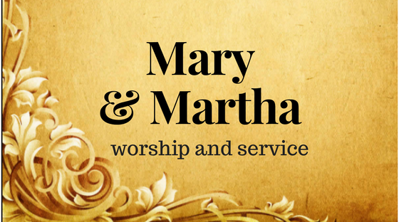

First United Methodist Church
30828 Irene Avenue P.O. Box 688
Lindstrom, Minnesota 55045
Phone: 651.257.4306
Email: office@lindstrommethodist.org
www.lindstrommethodist.org

July 21, 2019
9:00 a.m.

