Celebrating the Richness of God’s Grace

Proclaiming the Kingdom: beginning in Chisago County

+ Please stand if you are able
To enhance our worship, please turn off all cell phones and electronic devices.

Prelude and Silent Prayer Tari Eng Above All/ Jesus, Name Above All Names

Welcome, Announcements and Greeting

Call to Worship

Praise and Worship (please stand or sit as you wish)

Children’s Message

+Hymn #402 Lord, I Want to Be a Christian

Scripture Reading Luke 10:25-37

Message Pastor Tom Ervasti

+Hymn #375 There Is a Balm in Gilead

Prayers

Service of Holy Communion Hymnal #12-13
Invitation
Confession and Pardon
The Great Thanksgiving
Words of Institution
Lord’s Prayer
Sharing the Bread and Cup (gluten free available)
Offering (please bring your gifts as you come to commune)
Communion Blessing

+Benediction

+Hymn #389 Freely, Freely

+Dismissal
Leader: Go in peace to love and serve the Lord!
All: Thanks be to God!

+Postlude
Thank you for worshiping with us this morning!
This Week’s Calendar…

Monday, July 15
Our Secretary, Carol Schmidt, will be on vacation this week
4-6p Community Dinner at Zion Lutheran Church, Chisago City

Tuesday, July 16 Newsletter Deadline
7:00p Finance - lounge

Wednesday, July 17
7:00p Worship Team

Thursday, July 18

Friday, July 19
Pastor’s Day Off

Saturday, July 20
1:00p Visitation
2:00p Funeral for Lee Perry, Doug & Phyllis Perry’s son

Next Sunday, July 21 Mission Sunday
9:00a Worship
10:15a Fellowship

Last week’s offering: $2,321 Budgeted Weekly: $3,693
Monthly giving (July): $2,321 Budgeted Monthly: $16,004

Attendance last Sunday: 76

Children at First
- ‘Worship Bags’ are in the foyer for children to borrow

Please Pray For: Cole Anderson; Sandy Danielson; Brad Elshaug;
Brian Elshaug; Olga Determan; Phyllis Perry and family on the death of her son, Lee

Denver Mission Trip July 6 – 14: Please keep in your prayers Pastor Dale, Ashlee Nelson, Kaitlyn Nelson, and Jordan Anderson as they, along with 29 other youth and adults from Chisago Lakes Lutheran and Glen Cary Lutheran Churches return from doing mission work in Denver. Our group will share of their mission experiences during an upcoming Sunday Worship Service. The date is not yet determined.
Here’s What’s Happening…

Fellowship: Join us for coffee & treats in the fellowship hall following the service.

Our Mission Focus this month: Our UMC Cemetery – Crescent Beach Cemetery. Purchased in 1870 for $1.00, our cemetery is between Lindstrom and Center City just south of Hwy 8, on Crescent Beach Road. Funds are needed for the maintenance of the grounds.

Mission Envelopes: Mission Envelopes can be found in each pew rack. You are welcome to give to our monthly Mission Offering throughout the month using the designated envelope. Please make your check out to FUMC, marking “Missions” in the memo.

Memorial Wish List: The Memorial Committee is creating a Wish List of projects and things to be done around the church for the benefit of the church. If you have something to submit, please send an email to office@lindstrommethodist.org. Please provide a brief description of the project. Questions? See Greg Oien, Sharlene Arnold, or Linda Ploog.

A Congregational Conversation with our District Superintendent, Susan Neinaber, will happen on Sunday, August 4, immediately following our worship service in the sanctuary. In response to the Special General Conference’s decision in February to continue the UMC’s ban on same-sex marriage and gay ordination and the MN Annual Conference’s recent opposition to that ruling, Pastor Susan will be here to help us understand and process what the future of the MN Annual Conference and the UMC might look like and how that might affect our own congregation, congregations within our District, within our Conference, and within the whole UMC. At this time in our congregation’s history, this is an especially important conversation to be a part of. Please plan to attend.

August Mission Opportunity: Feed My Starving Children will be our mission focus in August. A packing opportunity will be Tuesday, August 13 at 6:00 – 7:30 p.m., 401 93rd Ave NW in Coon Rapids. Please contact Adrienne Stegmeir at aestegmeir@yahoo.com for more information.

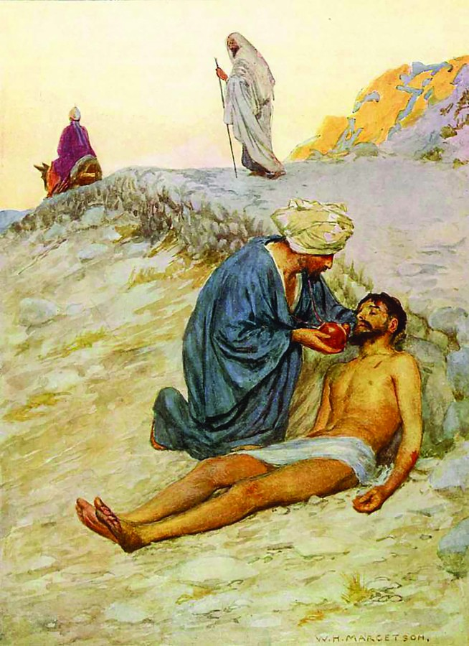

First United Methodist Church
30828 Irene Avenue P.O. Box 688
Lindstrom, Minnesota 55045
Phone: 651.257.4306
Email: office@lindstrommethodist.org
www.lindstrommethodist.org

July 14, 2019
9:00 a.m.

