Celebrating the Richness of God’s Grace

Proclaiming the Kingdom: beginning in Chisago County

+ Please stand if you are able
To enhance our worship, please turn off all cell phones and electronic devices.

Prelude and Silent Prayer
Welcome, Announcements and Greeting

Mission Moment Charis of Minnesota Prison Ministry

Call to Worship

Praise and Worship (please stand or sit as you wish)

Children’s Message

+Hymn (screen) You Are Mine

Scripture Reading John 1:29-42

Message Pastor Dale Stiles
+Hymn #357 Just as I Am, Without One Plea

Offering Lord, I Lift Your Name on High Bell Choir

+Offering Response #95 Praise God, from Whom All Blessings Flow

Prayers and Lord’s Prayer

+Hymn #344 Lord, You Have Come to the Lakeshore

+Benediction

+Dismissal
Leader: Go in peace! Be the Light of Christ!
All: Thanks be to God!

+Postlude

Thank you for worshiping with us this morning!
This Week’s Calendar…

Monday, January 20
4-6p Community Dinner at Zion Lutheran Church, Chisago City
6:00p Bell Choir

Tuesday, January 21 Newsletter Deadline
6:00p Finance – lounge
7:00p Church Council - lounge

Wednesday, January 22
6:00p Adult Bible Study
7:00p Confirmation
7:00p Worship Team Rehearsal

Thursday, January 23

Friday, January 24
Pastor’s Day off

Saturday, January 25

Next Sunday, January 26
9:00a Worship / Sunday School
10:15a Fellowship
10:30a Foundation Board - lounge

Last week’s offering: $1,898 Budgeted Weekly: $3,693
Monthly giving (Jan.): $6,559 Budgeted Monthly: $16,004

Attendance last Sunday: 69

Children at First
- ‘Worship Bags’ are in the foyer for children to borrow
- A Nursery for babies and toddlers is available every Sunday

Please Pray For: Cole Anderson; Sandy Danielson; Brad Elshaug;
Brian Elshaug; Olga Determan; Nate Clark; Baby Lilly; Ed Oswald; Lois Anderson

Here’s What’s Happening…

Fellowship: Join us for coffee & treats in the fellowship hall following the service.

Our Mission Focus this month: Charis of Minnesota. Charis is a non-denominational Christian ministry that presents God’s reconciling love in Jesus Christ to inmates in Minnesota correctional institutions. First UMC is collecting women’s personal care products for women recently released from prison. There is a box in the foyer for your donations. For more information visit Charis Ministries or talk to Scott Lecy or Gerry Gaudette.

Foundation Board Position Open: The Foundation Board is looking for an individual to fill an opening on its Board. No financial expertise is required.
If you are interested, please contact Donn Arnold for more details.

Online Bill Pay…do you use your computer to pay your bills on-line? If you do, you may want to send your church offering/pledge through the same on-line bill pay service. You can set up an automatic payment plan or a one time contribution. It’s easy:
* First, login to your bill pay account
* Select Add a Bill
* Select Create an account without an account number
(use the address and phone number below)
First United Methodist Church
P.O. Box 688
Lindstrom, MN 55045
651-257-4306

Please see Scott Lecy if you have any questions.

Unless your check or envelope designates an account, we assume it is for the General Fund. For bank-issued checks, if your contribution is for something other than General Fund, please enter in the "memo" line the account you wish your gift be recorded.

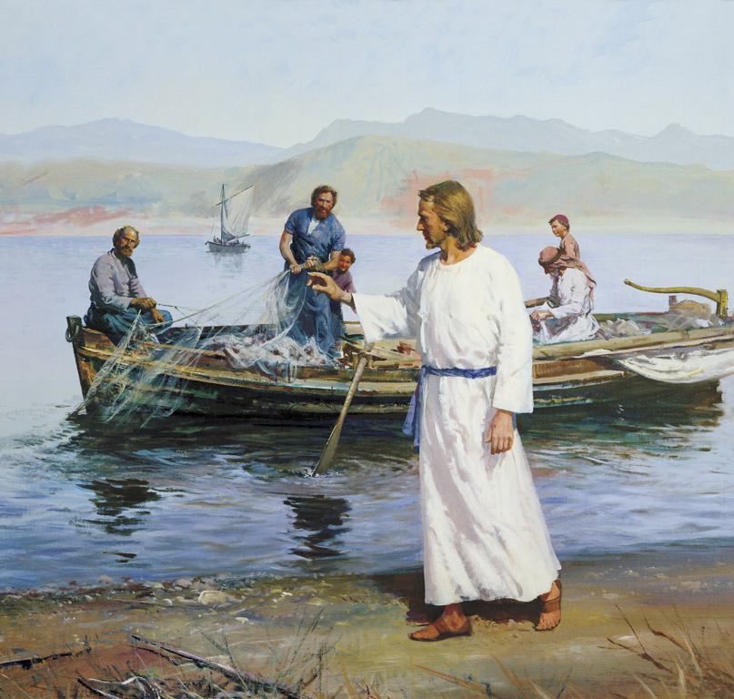

First United Methodist Church
30828 Irene Avenue P.O. Box 688
Lindstrom, Minnesota 55045
Phone: 651.257.4306
Email: office@lindstrommethodist.org
www.lindstrommethodist.org

January 19, 2020
9:00 a.m.

